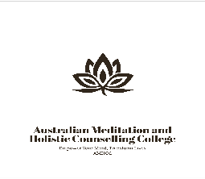

The Australian Meditation and Holistic Counselling College
Meditation Teacher, Holistic Coaching
& Holistic Counselling Training Program
Course Manual

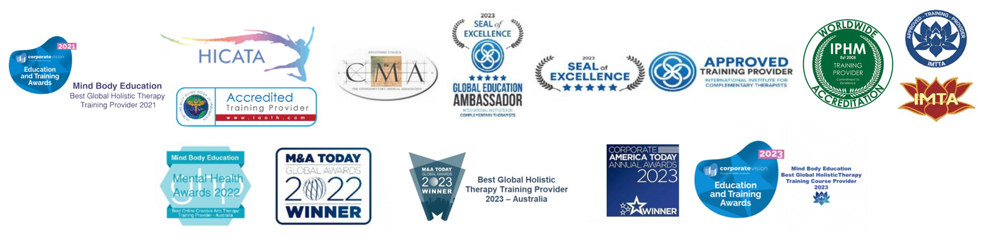

Our Courses
Certificate in Meditation Teaching & Holistic Human Development (Details on page 7)
(min 120 hours) – 12 modules.
Course duration: 3 months part-time
Part-time 10 hours study per week x 12 weeks
Full time 20 hours study per week x 6 weeks
IICT Recognised certification: (1) Meditation (2) Holistic counselling skills for meditation teachers


Certificate in Corporate Stress Management and Holistic Training and Assessment (Details on page 10)
(min 220 hours) 35 modules.
Course duration: 6 months part-time
Part-time 10 hours study per week x 26 weeks. Study break allowance (included in course durations) = 6 weeks
Full time 20 hours study per week x 15 weeks. Study break allowance (included in course durations) = 4 weeks
IICT Recognised certification: (1) Meditation (2) Holistic counselling skills for meditation teachers (3) Stress Management

Certificate in Advanced Meditation Teaching & Holistic Human Development (Details on page 12)
(min 360 hours) 24 modules
Course duration: 1 year part-time
Part-time 10 hours study per week x 46 weeks. Study break allowance (included in course durations) = 10 weeks
Full time 20 hours study per week x 23 weeks. Study break allowance (included in course durations) = 5 weeks
IICT Recognised certification: (1) Meditation teacher (2) Holistic counselling skills for meditation teachers

Advanced Practitioner of Meditation Therapies Training Course (Details on page 14)
(min 520 Hours) 32 modules
Course duration: 15 months part-time
Part-time 10 hours study per week x 64 weeks. Study break allowance (included in course durations) = 12 weeks
Full time 20 hours study per week x 32 weeks. Study break allowance (included in course durations) = 6 weeks
IICT Recognised certification: (1) Meditation (2) Holistic counselling skills for meditation teachers (3) Meditation therapist

Advanced Practitioner of Holistic Empowerment Coaching Training Course (Details on page 15)
(min 600 hours) 36 modules
Course duration: 19 months part-time
Part-time 10 hours study per week x 72 weeks. Study break allowance (included in course durations) = 12 weeks
Full time 20 hours study per week x 36 weeks. Study break allowance (included in course durations) = 6 weeks
IICT Recognised certification: (1) Meditation (2) Holistic counselling skills for meditation teachers (3) Meditation therapist (4) Holistic Empowerment Coaching

Master Practitioner of Holistic Empowerment Coaching Training Course (Details on page 17)
(min 840 hours) 48 modules
Course duration: 2 years part-time
Part-time 10 hours study per week x 100 weeks. Study break allowance (included in course durations) = 16 weeks
Full time 20 hours study per week x 50 weeks. Study break allowance (included in course durations) = 8 weeks
IICT Recognised certification: (1) Meditation (2) Holistic counselling skills for meditation teachers (3) Meditation therapist (4) Holistic Empowerment Coaching

Master Practitioner Holistic Counselling Training Course
(Details on page 19)
(min 1,100 hours) 53 modules
Course duration: 2 ½ years part-time
Part-time 10 hours study per week x 110 weeks. Study break allowance (included in course durations) = 20 weeks
Full time 20 hours study per week x 55 weeks. Study break allowance (included in course durations) = 10 weeks
IICT Recognised certification: (1) Meditation (2) Holistic counselling skills for meditation teachers (3) Meditation therapist (4) Holistic Empowerment Coaching (5) Holistic Counselling

Master Practitioner of Meditation Teaching and Holistic Counselling Training Course
(Details on page 21)
(min 1,340 hours) 63 modules
Course duration: 3 years part-time
Part-time 10 hours study per week x 134 weeks. Study break allowance (included in course durations) = 22 weeks
Full time 20 hours study per week x 67 weeks. Study break allowance (included in course durations) = 14 weeks
IICT Recognised certification: (1) Meditation (2) Holistic counselling skills for meditation teachers (3) Meditation therapist (4) Holistic Empowerment Coaching (5) Holistic Counselling

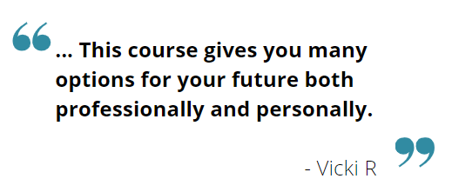
20 Professional Development courses (Details on page 24)
(min 80 hours each) 4 modules each

Part-time 10 hours study per week x 8 weeks.
Full time 20 hours study per week x 4 weeks.

Course Descriptions
Certificate in Meditation Teaching & Holistic Human Development (average 120 hours) – 12 modules.
Recognised certification: (1) Meditation (2) Holistic counselling skills for meditation teachers
Initials graduates can use: Mbe.MedTeach. (Mind Body Education Meditation Teacher)
Cost: Full- $1250, Payment plan: Deposit- $500, then $100 for 10 weeks
Curriculum Area | Competency | Minimum  Hours
Module One  Foundation studies in meditation | History and theory of meditation  Meditation in the western world  Brainwaves in meditation  Meditation techniques and styles  Developing meditation routines  Deepening and refining your practice | 10 hours
Module Two  Understanding the cause & effects of stress | Understanding stress  Psychological causes of stress  The Fight-or-flight response  Physiology of the stress response  Human behavioural manifestations of fight-or-flight Negative effects of the stress response in humans Positive stress  Stress management  Meditation development and practice  Chakra meditation  Concentrative meditation  Mindfulness meditation | 10 hours
Module Three  Foundations of human happiness | The psychology of happiness  Subconscious programming and reprogramming  States of mind  Fundamentals of self-image  The pursuit of happiness  Subconscious programming and reprogramming Guided meditation (creative visualisation) | 10 hours
Module Four  Tools for healing | Tools for healing  Positive thinking skills  Foundations of mind-body medicine  Meditation as a healing tool & hypnotic states  Journaling and gratitude  Understanding affirmations  Tools for developing a positive self-image  Meditation as a healing tool  Movement meditation | 10 hours
Module Five  Meditation styles and techniques | Poses and positions  Breathwork  Chakras and energy meditation  Guided meditation & creative visualisation  Mantras and affirmations in meditation  Gentle seated movement meditation (formally chair yoga) | 10 hours
Module Six  Teaching skills | Before you teach  Talking to groups & group leadership skills  Answering questions about meditation  Leading guided meditations  Overcoming obstacles to meditation practice  Creating safe and effective teaching environments  Group leadership skills | 10 hours
Module Seven  Working with specific groups | Teaching various meditation styles  Working with teenagers  Working with people with physical disabilities  Working with people with emotional disorders  Working with health care professionals  Business clients and corporate groups  Dealing with difficult clients | 10 hours
Module Eight  Counselling & coaching skills for meditation teachers | A client-centred approach  Your role as holistic counsellor  Building the foundations of happiness  Equipment  Outcomes of holistic counselling  The holistic counselling sessions  Assessment and introspection  Goal setting  Support Part  Listening skills  Holistic counselling tools for meditation teachers  - Life charting  - Reflection time  - Needs assessment chart  - Gratitude journal  - Worry time  - Positive thinking skills  - Affirmations  - Meditation as a healing tool | 10 hours
Module Nine  Designing and facilitating classes and workshops | Designing courses and workshops  Integrity and intentions  Setting the scene  Creating strong foundations for your groups  Understanding learning styles  Choosing your teaching style  Terrific teaching techniques and tips  Student management  Working with seniors  Choosing venues | 10 hours
Module Ten  Virtual, corporate and community settings | Corporate stress management workshops – Includes corporate teachers course manual.  Approaching community groups and organisations  Volunteer and community work  Teaching online – Using Zoom  Corporate stress management | 10 hours
Module Eleven  Holistic small business management | Ethics and Professionalism  Your public profile  Fundamentals of customer service  Maintaining student/client records  Charging for your services  Running a small home office  Joining organisations  Insurance and legalities | 10 hours
Module Twelve  Marketing: The key to success | Understanding the power of branding  Targeted marketing and advertising  Building your community  How to find and use free advertising  Public image  Final review  Your graduation | 10 hours

Certificate in Corporate Stress Management and Holistic Training and Assessment

(min 220 hours) – 35 modules.

Recognised certification: (1) Meditation (2) Holistic counselling skills for meditation teachers (3) Stress Management
Initials graduates can use: Mbe.CorpStressprac. (Mind Body Education Corporate Stress Practitioner)
Cost: Full: $2250, Payment plan: Deposit $500, then $100 for 20 weeks
Curriculum Area | Competency | Minimum  Hours
Unit One  Certificate in Meditation Teaching & Holistic Human Development  12 modules | See modules for the Certificate in Meditation Teaching & Holistic Human Development. | 120 hours
Unit two  Holistic Training and Assessment  19 modules | - Introduction  - Before you teach  - Your teaching space  - Integrity and intentions  - Setting the scene  - Creating strong foundations  - Learning styles  - Teaching styles  - Delivery techniques  - Student management  - Teaching online  - Teaching via Zoom  - Maintaining your cool  - Counselling and coaching skills for trainers and assessors  - Assessments  - Designing workshops  - Working from home  - Marketing your training and assessment courses | 20 hours
Unit three  Certificate in Corporate Stress Management  4 modules | - Corporate stress management and what a corporate stress management consultant does  - Understanding your corporate stress management students and clients.  - How to market your corporate stress management services and attract clients to your business.  - Conduct Corporate Stress Management consultations to assess your prospective clients’ needs.  - Assess and analyse your corporate clients’ needs.  - Design Corporate Stress Management proposals and provide quotes.  - Calculate fees and costs for your services.  - Source and book suitable venues for workshops when onsite workshops are not an option.  - Design class plans for corporate stress management courses and workshops  - Materials and equipment for conducting corporate stress management courses and workshops  - Holistic counselling for corporate clients  - Teach stress management and meditation to executives and upper management  - Tools and procedures for corporate clients  - Workplace health and safety  - Managing difficult and unwilling participants  - Assessing and reporting on productivity in the workplace  - Facilitating corporate retreats  - Providing ongoing programs  - Developing your professional reputation and public image  - Creating an online presence  - Developing confidence and professionalism | 80 hours

Certificate in Advanced Meditation Teaching & Holistic Human Development (min 360 hours) – 24 modules.

Recognised certification: (1) Meditation teacher (2) Holistic counselling skills for meditation teachers
Initials graduates can use: Mbe.AdvMedTeach. (Mind Body Education Advanced Meditation Teacher)
Cost: Full: $2650, Payment Plan: Deposit- $500, then $100 for 24 weeks
Curriculum Area | Competency | Minimum  Hours
Unit One  Certificate in Meditation Teaching & Holistic Human Development  12 modules | See modules for the Certificate in Meditation Teaching & Holistic Human Development. | 120 hours
Unit two  Certificate in Autonomic Nervous System Realignment Therapy  4 modules | - Introduction  - How you will be able to use autonomic nervous system reprograming  - The study of the ANS (autonomic nervous system)  - Dr Bruce Lipton  - Language  - The three brains  - The autonomic nervous system  - Neurochemicals  - The endocrine system  - Module summary  The Autonomic Nervous System (ANS)  The Amygdala  The Central Nervous System (CNS)  The Autonomic Nervous System (ANS)  What a nerve consists of  The evolution of human consciousness  Homeostasis  The heart brain  - The Gut Brain  - Reprogramming the autonomic nervous system by changing our perceptions and beliefs  - Finding beliefs to change  - Belief changing technique  Required Reading:  Beyond the Relaxation Response: How to Harness the Healing Power of Your Personal Beliefs by Herbert Benson MD  The Biology of Belief: Unleashing the Power of Consciousness, Matter and Miracles by Bruce H. Lipton PHD | 80 hours
Unit three  Certificate in Brain-Body Medicine  4 modules | - Introduction to Brain Body Medicine (Psychophysiology)  - The Role of the Brain Body Therapist (Psychophysiology Therapist)  - Introduction to Brain Body Medicine  - The Physiology of Belief  - Traumatic Beliefs  - The Power to Heal  - The Faith Factor and How to Provide it  - Providing Evidence for Your Clients  - Placebo – The Science Behind Brain Body Medicine  - Diagnosis and Seeking the Cause of Illness  - Guiding Clients to Self-diagnose and Healing  - Psychophysiology Diagnostic Tools  - How to Work with Damaging Belief Systems and Conditioning  - Medical Meditation  - Writing the Prescription  - Tools for the Psychophysiology Therapist  - Marketing Your Brain Body Therapy Practice  - Building Clientele  - Referring and Networking  Required Reading:  Mind Over Medicine: Heal Your Thoughts Cure Your Body by Lissa Rankin MD  Meditation as Medicine: Activate the Power of Your Natural Healing Force by Dharma Singh Khalsa MD | 80 hours
Unit four  Certificate in Advanced Holistic Counselling for Meditation Teachers  4 modules | - Introduction to Advanced Holistic Counselling  - Seeing Clients – Individual and Group Therapy  - Humanistic Psychology  - Emotions and Counselling  - Relationship Counselling and Counselling Couples  - Counselling Young Adults  - Trauma Counselling  - Counselling Clients with Depression  - Mediating  - Running Group Counselling and Therapy Sessions  - Fight or Flight and the Relaxation Response Review •  - Powerful Tools for Holistic Counselling  - Creative Expression Therapy  Required Reading:  The Games People Play by Eric Berne PHD | 80 hours

Advanced Practitioner of Meditation Therapies Training Course (min 520 Hours) 32 modules

Recognised certification: (1) Meditation (2) Holistic counselling skills for meditation teachers (3) Meditation therapist
Initials graduates can use: Mbe.MedTherp. (Mind Body Education Advanced Meditation Therapist)
Cost: Full: $3650, Payment Plan: Deposit- $500, then $100 week for 34 weeks
Curriculum Area | Competency | Minimum  Hours
Unit One  Certificate in Advanced Meditation Teaching & Holistic Human Development  24 modules | See modules for the Certificate in Advanced Meditation Teaching & Holistic Human Development | 360 hours
Unit two  Professional Development courses of the students’ choice from the list below  4 modules | As per the selected units | 80 hours
Unit three  Professional Development courses of the students’ choice from the list below  4 modules | As per the selected units | 80 hours

Advanced Practitioner of Holistic Empowerment Coaching Training Course (600 hours) 36 modules

Recognised certification: (1) Meditation (2) Holistic counselling skills for meditation teachers (3) Meditation therapist (4) Holistic Empowerment Coaching
Initials graduates can use: Mbe.EmpCoach. (Mind Body Education Empowerment Coach)
Cost: Full- $4250, Payment plan- Deposit: $500, $100 per week for 40 weeks
Curriculum Area | Competency | Minimum  Hours
Unit One  Certificate in Advanced Meditation Teaching & Holistic Human Development  24 modules | See modules for the Certificate in Advanced Meditation Teaching & Holistic Human Development | 360 hours
Unit Two  Certificate in Holistic Telephone Counselling  4 modules | - Introduction to telephone counselling  - Using Zoom and other online platforms for counselling  - Outline of the counselling call  - The seven core principles of telephone counselling  - Feelings are key  - Active listening  - Minimal encourages  - Reflection of content  - Exploration of feelings  - Open and closed questions  - Guidelines for summarising  - Basic telephone counselling communication guidelines  - Barriers to effective communication  - Listening skills  - Self-care  - Warnings and contras - When not to use telephone counselling  - Domestic violence and suicidal clients  - Role play exercises  Required reading:  The telephone counsellor’s role play handbook by Kerry Doolan  Telephone Counselling - A Handbook for Practitioners by Maxine Rosenfield | 80 hours
Unit Three  Certificate in Holistic Grief and Loss Counselling  4 modules | - Introduction grief and loss counselling  - What is grief?  - Healing the wounds of grief  - Grief takes time  - The journey through grief  - The grief processes  - The role of the holistic grief counsellor  - The pitfalls to avoid  - Influencing factors on grieving  - Resources and referrals  - Complicated grief  - Depressive grief and clinical depression  - Dealing with Acute Emergency Situations (AES)  - The grief counsellor’s role in AES  - Guidelines for grief counselling  - Counselling the dying  - Taking care of yourself  - Debriefing | 80 hours
Unit Four  Certificate in Holistic Trauma and Abuse Counselling  4 modules | - Introduction to trauma and abuse counselling  - Trauma  - How healing happens  - Foundational Relationship Attachment Concepts  - Abuse  - Treatments and Solutions  - The Role of Love in Healing from trauma and/or Abuse  - Earned Secure Adult Attachment  Required Reading:  Earned Secure Adult Attachment by Kerry Doolan | 80 hours

Master Practitioner of Holistic Empowerment Coaching Training Course (840 hours) 48 modules

Recognised certification: (1) Meditation (2) Holistic counselling skills for meditation teachers (3) Meditation therapist (4) Holistic Empowerment Coaching
Initials graduates can use: Mbe.MastEmpCoach. (Mind Body Education Master Empowerment Coach)
Cost: Full: $5250, Payment Plan: Deposit- $500, then $100 a week for 50 weeks
Curriculum Area | Competency | Minimum  Hours
Unit One  Advanced Practitioner of Holistic Empowerment Coaching Training Course  36 modules | See modules for the Advanced Practitioner of Holistic Empowerment Coaching Training Course | 600 hours
Unit Two  Certificate in Holistic Marriage and Relationship Counselling  4 modules | - Introduction to holistic marriage and relationship counselling  - Benefits of Holistic Marriage and Relationship Counselling  - Issues to consider  - Attachment Styles  - Communication Styles  - Issues for a couple to consider  - Love Maps  - Strategies for success in making marriages work  - Meditation as an effective modality in relationship mediation.  Required Reading:  Wired for Love:  How Understanding Your Partner’s Brain Can Help You Defuse Conflicts and Spark Intimacy by Stan Tatkin PsyD. MFT. | 80 hours
Unit Three  Certificate in Holistic Therapies for PTSD  4 modules | - Introduction to Post Traumatic Stress disorder  - Understanding PTSD  - The vagus nerves  - Foundational Relationship Attachment Concepts  - The effects of abuse and neglect in early life  - The effects of depression, stress and anxiety  - Treating depression  - Understanding panic attacks  - Working with grief and loss  - Tools for managing PTSD  - Using art therapy to treat PTSD  - Designing meditations for PTSD  - Talk therapy and PTSD  - Designing programs and workshops for PTSD  - Self-care for PTSD counsellors  Required Reading:  The body keeps the score by Bessel Van Der Kolk | 80 hours
Unit Four  Certificate in Inner-Child Work  4 modules | Types of Childhood Trauma  Theta waves and the realm of imagination  The wounded child  Tools, exercises and activities for working with the Inner-Child  Designing Inner-Child healing programs and workshops  Required Reading:  Heal Your Inner Child by Glenn Harrold FBSCH Dip C.H. | 80 hours

Master Practitioner of Holistic Counselling Training Course (1,100 hours) 53 modules – Not Available in the USA due to differing regulations from state to state. A minimum of 120 hours of this course must be completed in a face-to-face learning environment. This can be done via zoom (or other live conference call), in a classroom or via residential retreat.
Recognised certification: (1) Meditation (2) Holistic counselling skills for meditation teachers (3) Meditation therapist (4) Holistic Empowerment Coaching (5) Holistic Counselling
Initials graduates can use: Mbe.HolCouns. (Mind Body Education Master Holistic Counselling)
Cost: Full: $7250, Payment Plan- Deposit: $500, then $100 per week for 70 weeks
Curriculum Area | Competency | Minimum  Hours
Unit One  Master Practitioner of Holistic Empowerment Coaching Training Course | See modules for the Master Practitioner of Holistic Empowerment Coaching Training Course | 840 hours
Unit Two  Holistic Counselling Skills  1 module | - Creating safe environments  - Client Centred Therapy  - Understanding Anger  - Anger Management  - The Polyvagal Theory  - Ethics for holistic counsellors  - Client Assessment  Required Reading:  Holistic Counselling - A New Vision for Mental Health by Dr Patricia Sherwood  The Polyvagal Theory in Therapy: Engaging the Rhythm of Regulation (Norton Series on Interpersonal Neurobiology) by Deb A. Dana | 40 hours
Unit Three  Clinical Practice  1 module | Case Study Sessions  Students will take five volunteer clients through hour long counselling sessions each week for 10 weeks. Supervision and guidance will be provided via email to assist students with planning and facilitating the case study sessions.  Case study sessions maybe conducted in your own home, live via video conferencing (like zoom) or at a well-being centre in your local area.  Volunteers will complete a review and email this to the college after each session to provide feedback on the students counselling abilities. | 50 hours
Unit Four  Case studies exam  1 module | Write and submit an essay detailing the experiences gained through the case study sessions. | 10 hours
Unit Five  Holistic Psychotherapy  1 module | - Meditation as therapy  - Introduction to holistic psychotherapy  Psychodynamic Therapy  Family Therapy  Dialectical Behaviour Therapy  Interpersonal Therapy  Thought Field Therapy  Sand-play therapy  Rebirthing-breathwork  Neuro Linguist Programming  Hypnotherapy  Emotional Freedom Technique  Expressive Therapy  Drama and Role Play Therapy  Art Therapy  Acceptance and commitment therapy (ACT) | 80 hours
Unit Six  Master Practitioner of Holistic Counselling Thesis  1 module | Research and write a Master Practitioner of Holistic Counselling Thesis.  - Develop ideas based on acquired knowledge and accumulated experience  - Complete a major research project  - Create a substantial piece of writing to demonstrate in-depth knowledge of selected topics | 80 hours

Master Practitioner of Meditation Teaching and Holistic Counselling Training Course
(1,340 hours) 63 modules

Recognised certification: (1) Meditation (2) Holistic counselling skills for meditation teachers (3) Meditation therapist (4) Holistic Empowerment Coaching (5) Holistic Counselling
Initials graduates can use: Mbe.HolCounsMedTeach. (Mind Body Education Master Holistic Counselling Meditation Teaching)
Cost: Full: $9250, Payment Plan: Deposit- $500, then $100 per week for 90 weeks
Curriculum Area | Competency | Minimum  Hours
Unit One  Master Practitioner of Holistic Counselling Training Course  53 modules | See modules for the Master Practitioner of Holistic Counselling Training Course | 1,100 hours
Unit Two  Certificate in Meditation for Women in Transition and Women’s Mid-life Health and Wellbeing  4 modules | - Introduction to Meditation for Women in Transition and Women’s Mid-life Health and Wellbeing  - Defining the Mature Woman (mid-life)  - The Mature Woman in Modern Society  - What Older Women Really Want  - The Role of the Therapist Working with Women in Mid-life  - Health Issues for Mature Women  - Menopause  - Empty Nest Syndrome  - Marriage Breakdown  - Career Changes  - Sexuality and the Older Women  - Positive Health Habits for the Mature Woman ∙  - Tools and Exercises  - Diet and Nutrition  - Herbs  - Defining and meeting needs  - Hormones Research Project  - Working with women from diverse cultural backgrounds  - Working with Women Individually  - Working with Women in Groups  - Inner Goddess Workshops  - Running Women’s Retreats  - Open book exam based on the required reading book: The Female Brain  Required Reading:  The Female Brain by Dr Louann Brizendine | 80 hours
Unit Three  Certificate in Meditation for Men’s Health and Wellbeing  4 modules | - The Psychological issues for men’s health  - Physiological issues for men’s health  - Love and self-love  - Sex & sexuality  - Emotional guidance strategies  - Alienation  - Relationship breakdown  - Suicide ideation  - Alcoholism  - Drug dependence  - Working with Substance Abuse  - Working with Suicidal, potentially suicidal & self-harming clients  - Working with the emotionally disconnected male  - Tools for healing  Required Reading:  Manhood by Steve Biddulph  The Male Brain by Louann Brizendine | 80 hours
Unit Four  Meditation Course Design  1 module | Design a six-week meditation program comprised of six x 1 ½ hour sessions. Including mapping intent and processes of achieving the desired outcomes. | 80 hours
Unit Four  30 Hour case study  1 module | Students are required to provide three detailed references from students who have studied meditation with them for more than a total of 10 hours each
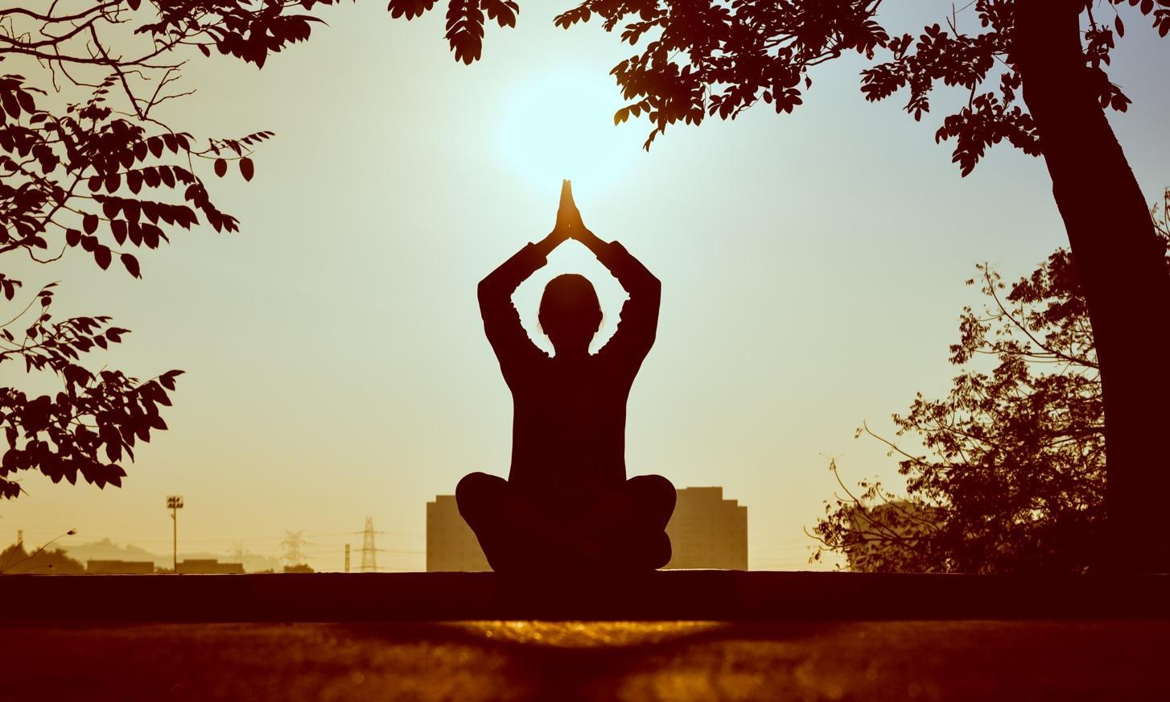
Professional Development Courses
20 Professional Development courses
80 hours each
Add-ons and electives
Cost: $550 (Up front fees)

Fast Facts:
Prerequisite: Certificate in Meditation Teaching & Holistic Human Development
Enrol in individual professional development courses at any time after completing the certificate course.
Students receive a certificate for each course completed.
Study hours:
Full-time: 4 weeks (20 hours per week)
Part-time: 8 weeks (10 hours per week)
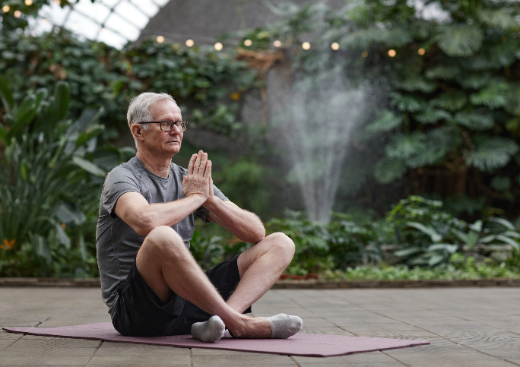

Certificate in Autonomic Nervous System Realignment Therapy (ANSR)
The Autonomic Nervous System is responsible for determining which neurochemicals and what amounts are released into our bodies; these chemicals create the physical environment our cells form and live in. This course explores the link between the way we chose to think (our perception), the neurochemicals those mental states determines and how chemical imbalances cause disease. Based on clinical evidence, ANSR investigates how and why, what we think influences our level of physical wellbeing and explains, in practical terms, how changing our thinking process will dramatically improve our physical health.

Certificate in Brain Body Medicine
This course explores why people can find themselves ‘trapped’ in old belief systems, negative thinking and habitual ideas that do not contribute to living happy or healthy lives. It provides a deeper understanding of the simple and practical tools we can use to help adopt a more positive and healthier thinking process. It includes in-depth exploration of how and why particular thinking patterns manifest into specific physical illness. Based on scientific research and humanistic psychology, this course takes the mystery out of ‘mind body medicine’ and brings a popular theory into a new light as concrete healing modality.

Certificate in Advanced Holistic Counselling Therapy
This course delves deeper into the practicalities of holistic counselling therapy. You will study communication skills (verbal and nonverbal), building counsellor/client relationships, relationship counselling, the holistic counselling process, mental and emotional wellbeing, counselling parents, counselling teenagers and releasing past trauma. This course also looks at the important ethical aspects of holistic counselling and will guide you in developing a completely professional practice.

Certificate in Holistic Marriage and Relationship Counselling
This course provides students with the skills and information required to counsel married couples, unmarried couples, families, siblings and others involved in close relationships who are seeking assistance to overcome difficulties within the relationship.
In this role the Marriage and Relationship Counsellor will often act as a mediator and will provide the couple (or family) with positive communication skills and life tools to assist them in expressing their emotions in a positive and non-blameful manner, taking responsibility for their part in the relationship breakdown, setting goals and identifying desired outcomes for themselves and the relationship.

Certificate in Holistic Trauma and Abuse Counselling
Trauma and Abuse Counselling works to assist people whose lives have been adversely affected through being abused or traumatised either physically and/or psychologically. This may include sexual abuse, violent physical attack, bullying at home and school or in the workplace, domestic violence, witnessing or being involved in a traumatic incident or accident.
The Trauma and Abuse Counsellors provides support, guidance and resources for the client to overcome the trauma and begin to implement strategies and positive life habits that allow them to live a normal, balanced life again.
Trauma and Abuse Counsellors must also have a thorough understanding of referral networks and the cycle of domestic violence as some of their clients may still be experiencing abuse and require guidance in removing themselves from danger.

Certificate in Holistic Grief and Loss Counselling
Grief and Loss counselling become necessary when a person is so disabled by their grief and so overwhelmed by their loss, that their normal coping processes are disabled or shut down.
People may require Grief and Loss Counselling after the death of a loved one, after a long term relationship ends or even after losing their job. All people experience grief and loss differently. Grief counselling facilitates the expression of emotion and thoughts about the loss, including their feeling sad, anxious, angry, lonely, guilty, relieved, isolated, confused, or numb.
Holistic Grief and Loss Counsellors are able to provide clients with coping skills, emotional support and resources (and sometimes referrals) to help support them through the normal grieving process and also through what is known as ‘complicated grief’ (which occurs when the client gets stuck in, or does not progress through, the natural stages of grief on their own.

Certificate in Meditation Therapy for the Management of Depression and Anxiety
This course provides people with the tools required to self-manage depression and anxiety as well as better manage stress in daily life. As we witness the distressing increase in the number of people dependent on antidepressant drugs to cope with daily life, we realise how essential it has become to provide natural and self-managed alternatives to medication as a standalone treatment. Teaching Meditation for Depression and Anxiety is particularly useful for practitioners who wish to focus on the epidemic of stress, depression and anxiety-related disorders that are rampant in our society.

Certificate in Meditation Therapy for the Management of Pain and Healing
Modern research has confirmed the age-old wisdom that meditation has the ability to cure many physical and psychological ailments. This training program allows practitioners to specialise in the area of self-empowered healing and personal pain management and covers self-healing, recovery and meditation for pain management. This is an excellent course for anyone who is interested in working in the holistic healing field and combines particularly well with Chair Yoga teaching.

Certificate in Meditation for Children
This is a great course for those with a special interest in children. Teaching meditation to children is very different from teaching adults and offers young students a fantastic first step toward a lifetime of health and happiness. The kids’ classes are lots of fun and high energy. Children learn the basics of traditional yoga poses through role play. They learn about how their bodies work, how to look after themselves and how to be calm and relaxed as well as developing a myriad of important positive life skills to help them cope with the pressures of daily life. Learning meditation also significantly contributes to better sleeping patterns for children and a wide range of other health and emotional benefits for kids and their parents.

Certificate in Prenatal Meditation
Prenatal meditation and the use of meditation during childbirth contribute significantly to a more peaceful, faster and less painful birthing experience. It also helps to create a calmer, happier baby and a more confident, relaxed mother. This is a wonderful and rewarding field to teach meditation in and the program you will learn to facilitate can be offered as a two-day workshop or adapted for a weekly class structure.

Certificate in Meditation Therapy for Men’s Holistic Health and Wellbeing
This course offers a fantastic opportunity to explore the issues many men face in our modern society. Subjects include men and communication, understanding anger, facing fear, sexuality, men’s roles in modern society, rites of passage, fatherhood, men’s health, and cultivating creativity for men. This course also covers running workshops and retreats for men, including warrior-style workshops and celebrations of manhood.

Certificate in Meditation Therapy for Women’s Midlife Health and Wellbeing
This course will prepare you to support women in transition and guide them with beautiful tools that assist in developing high self-esteem, self-empowerment, inner strength, trust, self-love, joy and forgiveness. You will also learn about the physical effects of menopause, explore social attitudes regarding women and aging and develop an understanding of the effects of diet, exercise and meditation during menopause. This course also covers running workshops and retreats for women, including goddess-style workshops and celebrations of womanhood.

Certificate in Meditation Therapy for Weight Management
This course will assist you in developing a good understanding of the causes underlying weight problems, eating disorders and obesity; the physical and emotional impact these conditions have on people’s health and quality of life and teach you how to facilitate workshops which assist people in accomplishing a healthy body weight, developing and maintaining healthy lifestyles, healthier mindsets and a more positive self-image. You will also be able to assist people in adopting healthy eating habits, basic exercise programs and meditation routines and guide them towards developing positive thinking skills. Your clients and students will be exposed to a new understanding of why they have weight issues and will be inspired to apply new, practical and achievable ideas. They will have the resources and support they need to overcome the root causes of their weight issues and move forward into a healthier and happier future.

Certificate in Corporate Stress Management
Stress can have a major effect on work performance. Some of the consequences include absenteeism, diminished performance, negative attitude and cynicism, decline in commitment and creativity, and a decreased ability to concentrate, learn and interact with other employees. Stressed workers can also develop a range of negative health symptoms including insomnia, headaches, back pain, gastrointestinal disorders, fatigue, anxiety, irritability and depression. This course focuses on developing your skills as a Corporate Stress Management Consultant and using your qualification to help build strong workplace stress management programs, better self-esteem among employees, stronger workplace teams and greater productivity levels for business owners.

Certificate in Elemental Movement Meditation
Movement meditation encourages natural and authentic self-expression and provides a means of re-connecting with our most primal, graceful and authentic self. It opens our creative life force, expands awareness and develops equanimity.
Students will experience the benefits of movement meditation and learn how to facilitate courses and workshops for a range of different groups.

Certificate in Sound Therapy and Vibrational Healing
A living cell is a blend of resonant frequencies — vibrational healing influences cellular health by changing its frequency through sympathetic resonance. Sound Therapy acts as a catalyst for healing by transferring energy frequencies into the physical body. This type of therapy has been used in medicine in both treatment and diagnostics for many years.
Learn how and why this intriguing therapy works and experience Sound Therapy and Vibrational Healings self-evident benefits for yourself.

Certificate in Holistic Therapies for PTSD
Based on the ground-breaking work of psychiatrist, author and educator, Bessel van der Kolk, who has been at the forefront of research in the area of post-traumatic stress the 1970s. Dr van der Kolk has spent his career studying how children and adults adapt to traumatic experiences and have interpreted his findings into his book; The Body Keeps the Score.
Students will explore what PTSD is, how it is recorded in the brain, and how it affects the development of the cells. You will also discover very effective ways for supporting your clients to move beyond PTSD into self-empowerment and improved mental, emotional and physical health.

Certificate in the ART of Meditation
Creating art is a type of meditation that can have fast and profound healing benefits. Art making is a natural vehicle for meditation, relaxation and self-connection. It increases awareness and emphasises acceptance of feelings and thoughts without judgment. It is a catalyst for relaxation of the body and the mind.
Art therapy is useful where talk therapy is ineffective because the client cannot express their issues in words. It assists clients to explore, express and accept their thought and feelings in a peaceful and self-empowering way.

Certificate in Inner Child Work
So many, if not all, emotional issues and mental health problems can be traced back to childhood trauma. Inner child work is a way of effectively identifying and resolving childhood trauma. It is focused on the experiences, emotions and unconscious beliefs still being held onto by the adult as a result of childhood experiences. It helps to develop a sense of safety as well as connecting us to the joy, innocence, playfulness, openness and confidence of childhood.

Certificate in Holistic Telephone Counselling
This course prepares students to offer telephone and online counselling therapy for clients who are unable to attend in person for various reasons. These reasons may include family or work commitments, disability, location, lack of transport or isolation.
Telephone counsellors need special skills to ensure the client experiences as close as possible, the safe and nurturing environment the counsellor would provide in a face-to-face consultation.

